EAN 5901804191350 | OPCO NUMBER T2003
Vendor Art. Nr 1804191350

Aire

Main description
New technologies allow radiator designers to introduce new and uncommon forms. Original design, highest quality and functionality make Aire a great choice not only for bathrooms, but also for other spaces in modern interiors.

Key points
- Unique form
- Original and functional decorative element
- Ultimate minimalism and practical value

Features and benefits
- Highest quality low carbon steel ensuring product longevity
- Every rail 100% leak tested
- Oxsilan® passive rust protection process
- Great towel hanging capability
- High quality double layer powder coating
- Up to 8 Year Guarantee
- Increased resistance to chemicals, temperature variations and mechanical damage
- Easy installation (solid wall fixing kit included)
- Easy cleaning and maintenance
- Made to EN 10305-5
- Bleed valve included

Specifications
Height (mm): | 1555
Width (mm): | 300
Depth (mm): | 32
Colour: | Winter Sky
Heat output (W): | 600
Heat output (BTUs): | 2047
Connection type: | ZX
Connection spacing: | 50
Wall to centre of inlet (mm): | 67-75
Operating pressure (MPa): | 1
Maximum operating temperature (°C): | 95
Material: | Carbon steel
Surface finish: | Powder coating
Weight (kg): | 10.3

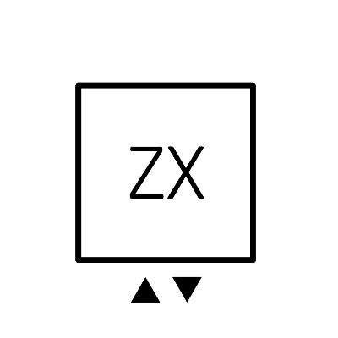
Connection diagram

