EAN 5901804191077 | CB NUMBER T1203
Vendor Art. Nr 1804191077

SALISBURY

Main description
Classic radiator distinguished by a functional arrangement of profiles, allowing easy access to towel rails. Can make a statement in any bathroom, kitchen or recreational space. Features robust rectangular profiles and a frame with rounded sides.

Key points
- Simplicity and style
- High power output
- A form which is both minimalist and sophisticated
- Adheres very close to the wall

Features and benefits
- Highest quality low carbon steel ensuring product longevity
- Excellent heat output
- Every rail 100% leak tested
- Great towel hanging capability
- Oxsilan® passive rust protection process
- High quality double layer powder coating
- Up to 8 Year Guarantee
- Increased resistance to chemicals, temperature variations and mechanical damage
- Easy installation (solid wall fixing kit included)
- Made to EN 10305-5
- Easy cleaning and maintenance

Specifications
Height (mm): | 1635
Width (mm): | 540
Depth (mm): | 40
Colour: | Sparkling Gravel
Heat output (W): | 794
Heat output (BTUs): | 2709
Connection type: | SX
Connection spacing (mm): | 500
Wall to centre of inlet (mm): | 57-65
Operating pressure (MPa): | 0.8
Maximum operating temperature (°C): | 95
Material: | Carbon steel
Surface finish: | Powder coating
Weight (kg): | 24.4

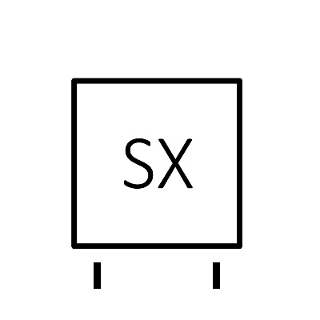
Connection diagram

